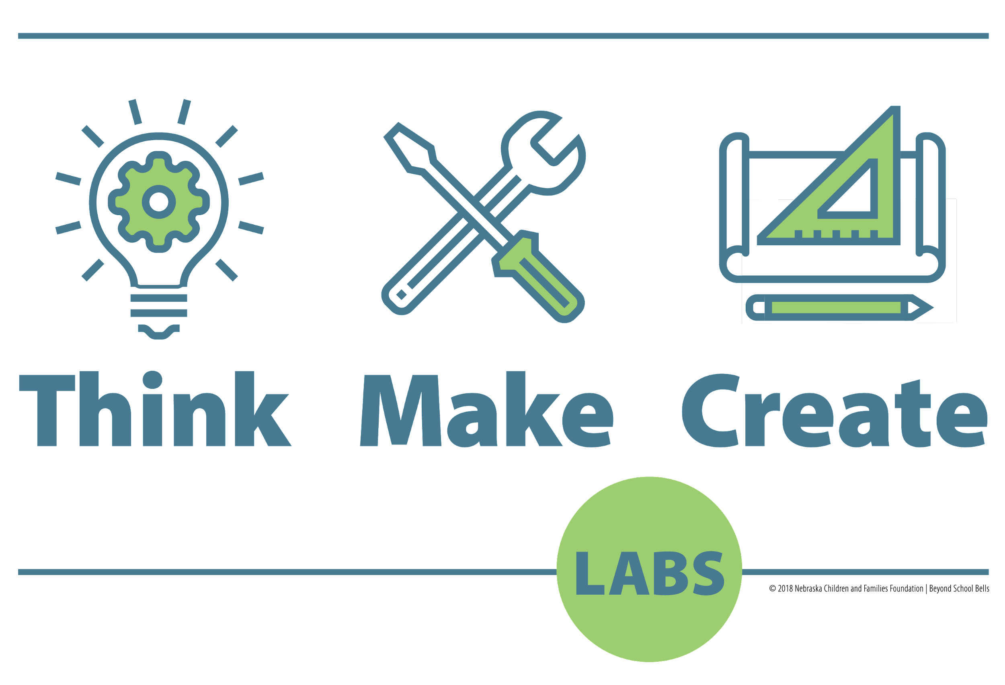
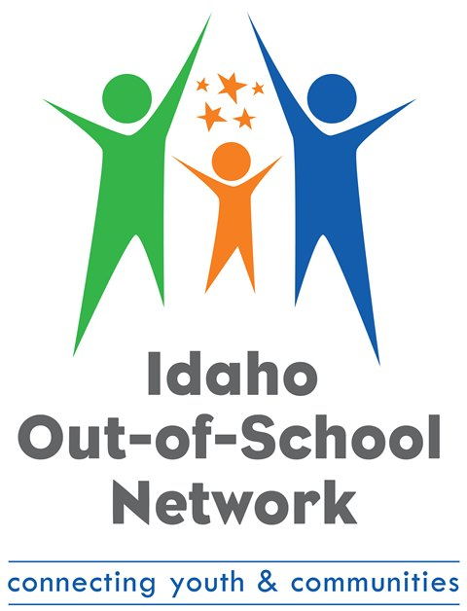
Idaho Out-of-School Network’s Think Make Create
Summer 2022 Award
REQUEST FOR PROPOSAL (RFP)

- Introduction…………………………………………………………………………….1
- Timeline………………………………………………………………….………….…..2
- Eligibility………………………………………………………………………………..4
- Target Populations ………………………………….………….……………………...5
- Program Quality………………………………………………………………………..6
- Program Implementation Reporting and Assurances………………….………….6
- How to Apply………………………………………………………...………………...6
- FAQ……………………………………………………………………………….…….6

Equal Opportunity Statement
Jannus, Inc. shall abide by the requirements of 41 CFR sections 60-1.4(a) (7), 60-300.5(a) and (d), 60-741.5(a) and (d), and 29C.F.R. Part 471, Appendix A to Subpart A, if applicable. These regulations prohibit discrimination against qualified individuals, including on the basis of race, color, religion, age, gender, pregnancy, national origin, mental or physical disability, genetic information, sexual orientation or gender identity, veteran status or disability, military status, or any status protected by federal, state or local law and require affirmative action by covered prime contractors and subcontractors to employ and advance in employment women, minorities, qualified protected veterans, and individuals with disabilities.

Overview
This funding is intended to expand access to, improve the quality of, and create increased equity within STEM-rich youth programs in Idaho. This opportunity was created to support community-based organizations that either host a mobile makerspace or intend to use curriculum related to the Idaho STEM Ecosystem’s Think Make Create (TMC) mobile makerspace labs project.

The TMC Summer Award is funded by the Idaho Department of Health and Welfare and awarded by the Idaho Out-of-School Network. The grants are authorized under the Coronavirus Aid, Relief and Economic Security Act (CARES Act) and the Coronavirus Response and Relief Supplemental Appropriations Act of 2021 (CRRSAA) and the American Rescue Act Plan (ARPSA).

Idaho Out-of-School Network (ION) was granted the Idaho Community Grant from the Idaho Department of Health & Welfare to distribute funds to qualifying programs or organizations, monitor the use and provision of services, and support the out-of-school time work across the State.

Purpose
Applicants must propose to use funds for at least one of the following purposes:
- Expand access to STEM activities and TMC curriculum in order to serve more youth, with an emphasis on children and communities most impacted by the pandemic who lack access with a focus on equity
- Increase the quality of the curriculum used by TMC, and expand or enhance materials and services offered to youth, or
Definitions
- Think Make Create (TMC) Labs
TMC labs are free-standing trailers and/or vehicles capable of providing mobile makerspace activities in communities across Idaho. TMC labs are a collaborative initiative of the Idaho STEM Ecosystem, co-managed by the Idaho Out-of-School Network, the University of Idaho Extension, 4-H Youth Development Program, and are owned and operated by independent youth organizations across the state.
- Think Make Create (TMC) Curriculum
TMC Curriculum is defined as inquiry-based making, tinkering and engineering activities for youth between 3 and 18 years of age. The curriculum is detailed at www.idahooutofschool.org/STEM and is subject to the policies included on that website.

- Dimensions of Success (DoS)
An evidence-based protocol for observing and coaching educators providing STEM-rich youth programs. Youth programs using TMC labs and/or curriculum will be scheduled for an observation during the period of the grant. The DoS protocol was created by and is maintained by the PEAR Institute and can be seen at https://www.pearinc.org/dimensions-of-success.
- TMC Usage Report
A short report form used by educators and/or TMC hosts to record the use of TMC labs and TMC curriculum. The report is to be completed at least monthly by hosts or grantees. Results help improve the program, align evaluation and measure collective impacts. TMC provides both online and downloadable versions of the Usage Report.
Timeline
Application Open: May 2022
Award Q & A: June 15th, 11:30 am (MT) Shop Talk
Application Closes: August 1st, 2022

Eligible Applicants

Eligible applicants are limited to any of the following:
- Organizations offering summer programming using a TMC lab and/or curriculum who have received TMC training
- Programs providing direct services to youth ages 5-13 in Idaho;
- Programs that will operate during June, July and/or August 2022.
Ineligible Organizations/Agencies
- For-profit businesses;
- Programs that are receiving other funding from the Idaho Community Grant Program through Idaho Department of Health & Welfare from June-September 2022;
- Programs not active between June - August 2022.

Funding Amounts

Applicants can apply for the amount needed per TMC lab or site for programming. ION reserves the right to offer the amount the TMC leadership team feels is justified based on submission quality, filed usage reports and project needs.

Maximum: $45,000
The budget narrative must include specific cost details. (For example: Staff costs will include 1 full-time TMC Lead Educator at $20 per hour and 2 full-time STEM coaches at $18 per hour, all for 200 hours total, for a total of $11,200.)
Programs must show how receiving these funds will increase capacity—serve more children than otherwise possible.
Target Populations

Organizations that serve the following historically underserved population groups, or communities without current programming, will receive additional points during the scoring process. To find current programs statewide please visit the Program Directory. Following is a list of underserved peoples:
- Rural
- Black
- Indigenous
- Latinx
- Youth with disabilities
- Youth experiencing homelessness
- Youth in foster care
- English language learners
- Youth receiving free or reduced-price lunch
- Migratory youth
- LGBTQIA youth
Program Staff Requirements
Applicants are invited to use a portion of this award to register and secure lodging for the in-person, two day 2022 Power Up Summit on September 29-30, 2022, at the Shoshone-Bannock Casino Hotel in Fort Hall. Applicants are encouraged to budget for related travel costs (lodging, travel, etc.) and Summit registration.
At least one member of the organization, director or staff that supervises children and who intends to provide TMC programming must participate in a TMC training prior to utilizing the grant. To schedule a refresher course, additional staff training or modify and/or expand TMC curriculum, contact Wendy Wilson, wlwilson@jannus.org.
Eligible Activities
- The purchase of consumable supplies for youth engaged in making, tinkering and/or engineering, Including but not limited to the TMC SUPPLY LIST HERE.
- The purchase of storage totes, and/or new tools expanding use of and distribution of TMC activities.
- Staffing & operation costs to support TMC and TMC curriculum.
- Direct Travel expense and/or mileage incurred delivering programs associated with TMC labs and TMC curriculum.

THE ADMINISTRATION CAP FOR FUNDING IS 10%.

Administration is defined as persons in positions of support to their organization; such as internal and external communications, scheduling, bookkeeping, data entry.

Awardees will be subject to 45 CFR 98.56 https://ecfr.io/Title-45/Section-98.56.
Ineligible Expenses
This funding must not be used towards:
- Building improvements and renovations
- Landscaping
- The lease or purchase of a vehicle
- Personal debt or personal credit card payments not related to your business
- Licensing fees or permits
- Subscriptions

Program Quality Supports
All programs are highly encouraged to use the support and guidance in the Idaho Building Blocks for Out-of-School Time Quality to assess and improve quality in various program areas. Support will include coaching and technical assistance from ION staff. The system is self-assessment based, and programs can create a Continuous Quality Improvement Plan, which includes four steps: Plan, Do, Check and Adjust. Awardees will have access to additional support via the Dimensions of Success program associated with the Idaho Out-of-School Network.

Program Assurances
In accepting this award, applicants agree to the following:
- To avoid duplication of programming, providers will confirm with their local public school district that similar programming is not offered;
- Participation in any data collection that is required by the state or federal government for the use of this funding;
- Unannounced, on-site monitoring visits conducted by ION staff or their subcontractor at any time during the programming;
- The application must be completed by the entity that maintains full responsibility and therefore is the operator of the program, regardless of any partnership, volunteer, or subcontract arrangements;
- Programs must make every reasonable effort to be accessible for individuals with disabilities. Additionally, all materials should be made available in accessible formats (e.g., printed, digital, and web-based information);
- A commitment to embracing diversity, equity, and inclusion integrating these concepts into daily activities to create a healthy program environment for all youth and staff;
- Provide monthly and a final TMC usage report to ION no later than September 15, 2022.
- All funds are to be used directly by the recipient for the purposes outlined in the grant proposal submitted to ION.
- Agrees to use these funds for direct expenses associated with operating the TMC lab or using TMC materials and curriculum within 3 months of the award notification.

Submission Process and Deadline
Applications are completed through this link. If the person applying has not made a grant portal account with ION yet, they must first register.
Applicants must fill out a proposal budget using the template below. Budget amount should equal the award request amount and include details under each category. Proposal Budget Template
Applications will not be accepted past August 1st, 2022. Applications must be submitted in the Blackbaud grant portal.
Award requirement questions can be submitted via email to danielizabeth@jannus.org.
Applicants that experience any technical difficulties with their Blackbaud account should contact Blackbaud support.

Selection and Notification
Award applications will be reviewed and approved by ION Director and TMC Leadership Team.
Programs will be notified via email within 10 business days of submission if the application was selected or not.

FAQ

How do I apply for this award?
You will register through the Blackbaud grant portal. Once logged in, eligibility is determined through an initial questionnaire and if requirements are met, you will be able to access the application form, complete the necessary fields and submit required documents.
How long do I have to spend the funds if awarded?
The full award amount received needs to be used throughout the timeframe of summer programming, June - August 2022. If your program is asking for funds to provide a one time TMC event for instance, rather than ongoing weekly programming, that must be explained in the application.
We received the Idaho Community Programs for Youth Round III, Summer of Innovation Award. Are we still eligible?
Yes, as long as you meet the requirements outlined in the RFP and funds from this award are solely dedicated to the TMC related costs listed in the eligible activities. If your approved ICPfY budget included costs for staffing, you may not use the TMC grant towards that cost.
My program serves youth 4-16 year olds. Are we eligible?

It is allowable to serve additional youth ages within the program, but the funds from this grant are required to be spent on 5 to 13 year olds. All youth in your program may benefit from this, however the purchase or expense must be justified to improve access to, or reduce barriers to participation for ages 5 to 13.

