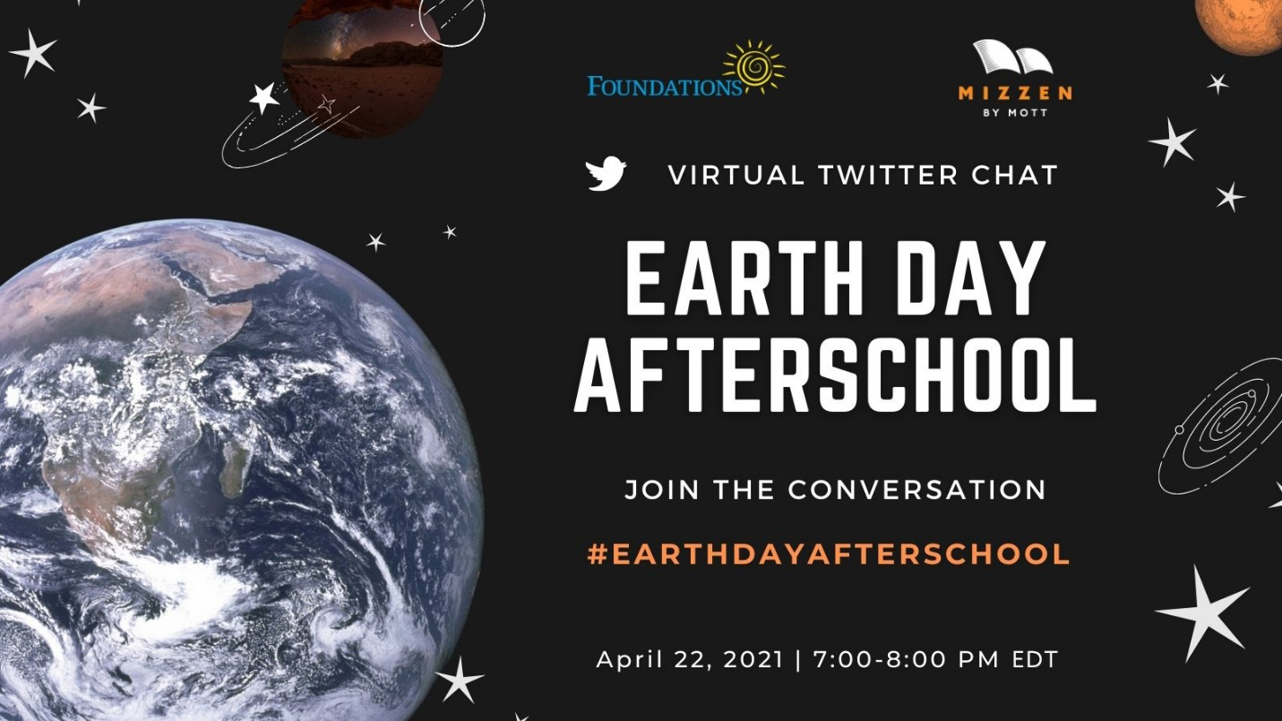
Overview:
For Earth Day 2021, Foundations, Inc. is teaming up with Mizzen by Mott to host a Twitter Chat for the afterschool field. #EarthDayAfterschool will take place on April 22 and engage afterschool and summer educators in conversation with leading content creators in STEM, environmental sustainability, climate change and youth environmental leadership. The conversation will be framed around 5-7 questions. Invitees include the afterschool field, summer and youth development programs, youth leadership initiatives, Mizzen STEM partners and organizations that are dedicated to the health and sustainability of the environment.

Questions for the Twitter Chat:
- Why is educating our youth about planet Earth, climate change and sustainability important to you?
- What’s a little-known fact about climate change or sustainability everyone should know?
- What are your favorite activities in Mizzen for teaching about the Earth and climate?
- What’s the most important thing we can do NOW to protect our planet?
- How does working on local environmental and health issues, like air quality and city parks, help save the planet?

Join us! Partners are invited to participate by:
- Joining the conversation on Twitter at #EarthDayAfterschool and responding to questions.
- Promoting the event on social and/or by email.

