Idaho Out-of-School Network Survey
Summary of Results, June 2018
Jocelyn Cullers, Boise State University Institute for STEM & Diversity Initiatives

OVERVIEW OF RESPONDENTS
- Of the 136 survey respondents:
  - 82% (112) of respondents include STEM as an intentional part of their afterschool, summer, or other out-of-school program. These respondents are categorized as “STEM programs” in the analysis.
  - 8% (11) of respondents do not include STEM as an intentional part of their program. These respondents are categorized as “Other programs” in the analysis.
  - 10% (13) of respondents did not indicate whether STEM is an intentional part of their program and did not answer any questions beyond this one. THEY ARE THEREFORE EXCLUDED FROM ANALYSIS BEYOND THIS OVERVIEW SECTION.
- Calculations are based on the 123 (112 STEM programs and 11 Other programs) respondents who answered questions beyond the preliminary information section.
- Of the 112 STEM programs, most (46, 41%) are in the Public Library sector.
- Most (60%, 67 of 112) of the respondents who provide STEM programming are primarily an afterschool or summer program provider.
- Within each organization primary function, those providing STEM programs are as follows:
  - STEM program/curriculum provider: 95% (19 of 20)
  - Afterschool or summer program provider: 87% (67 of 77)
  - Granting/funding organization: 25% (1 of 4)
  - Other (aggregated): 71% (25 of 35). Of the "Other" primary functions:
    - 18 are in the Public Library sector; 78% (14) of these offer STEM programs.
    - 8 are in the Public School K-12 sector; 63% (5) of these offer STEM programs.

YOUTH PARTICIPATION
- Number of students served ANNUALLY by STEM Programs:
  - 14% (16 respondents) serve 51 - 100 students
  - 10% (11) serve 201 - 300 students
  - 9% (10) serve 31 - 50 students
  - 5% (6) serve fewer than 30 students
  - A combined 21% (24) serve more than 1,000 students
  - 10% (11) did not provide a response
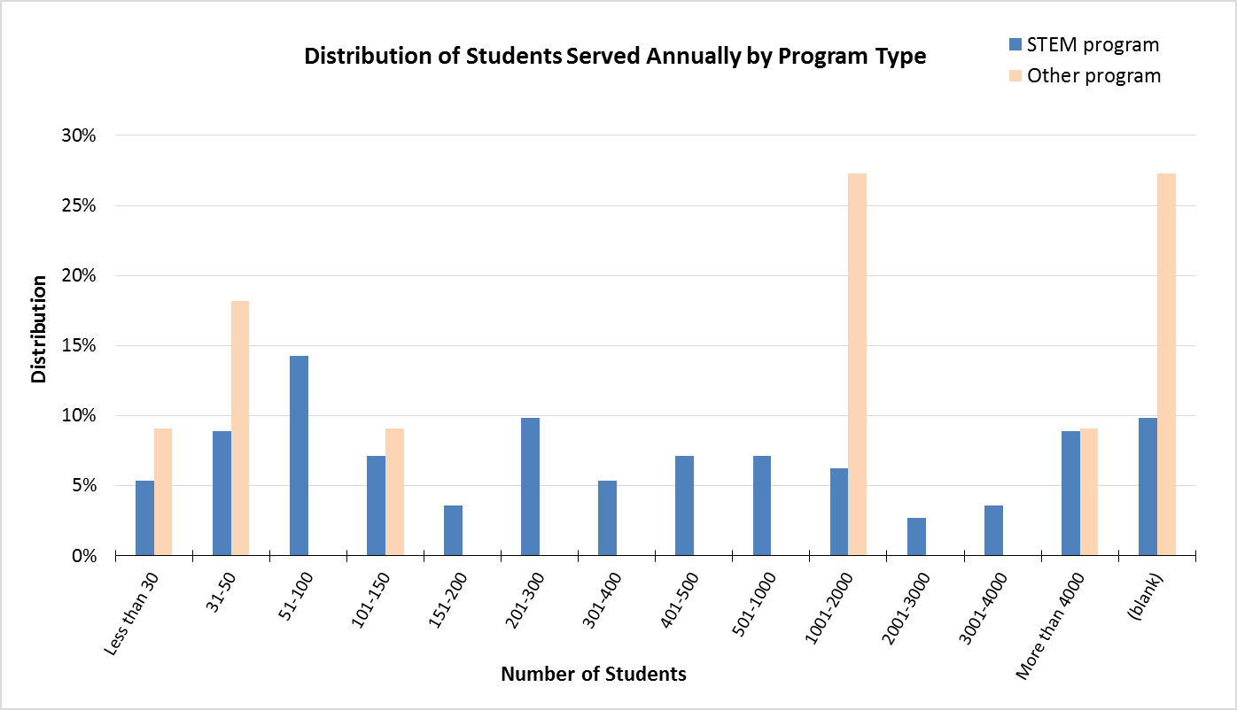
- Number of students regularly participating in STEM Program activities EACH WEEK across all sites:
  - 11% (12 respondents) have 10 - 19 weekly participants
  - 10% (11) have 20 - 29 weekly participants
  - 9% (10) have 100 - 124 weekly participants
  - A combined 6% (6) have 300 or more weekly participants
  - 7% (8) have fewer than 10 weekly participants
- STEM programs serving more than 2,000 students annually came from the public library, public schools K-12, non-profit organization, and higher education institution sectors.
- Amount of STEM instruction:
  - 27% (30) of STEM program respondents estimate students receive 1 to 20 hours of STEM instruction during the school year.
  - 29% (32) of STEM program respondents estimate students receive 1 to 10 hours of STEM instruction during the summer. This is closely followed by 25% (28) who say students receive 10 to 20 hours of STEM instruction during the summer.
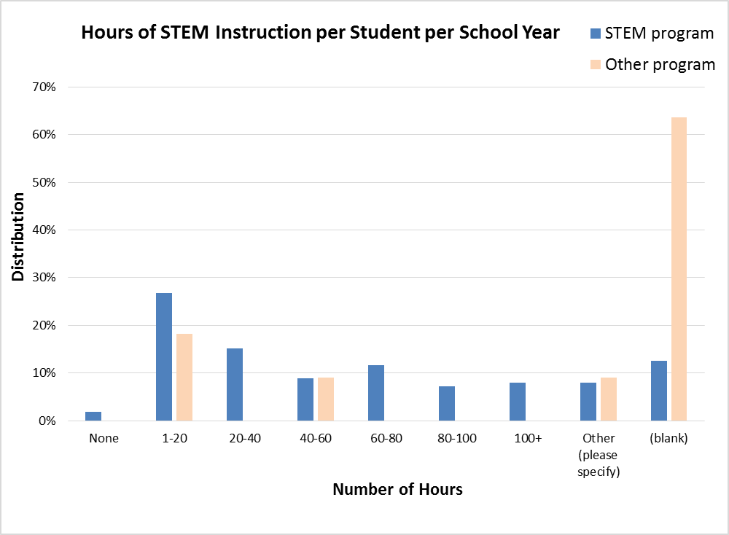
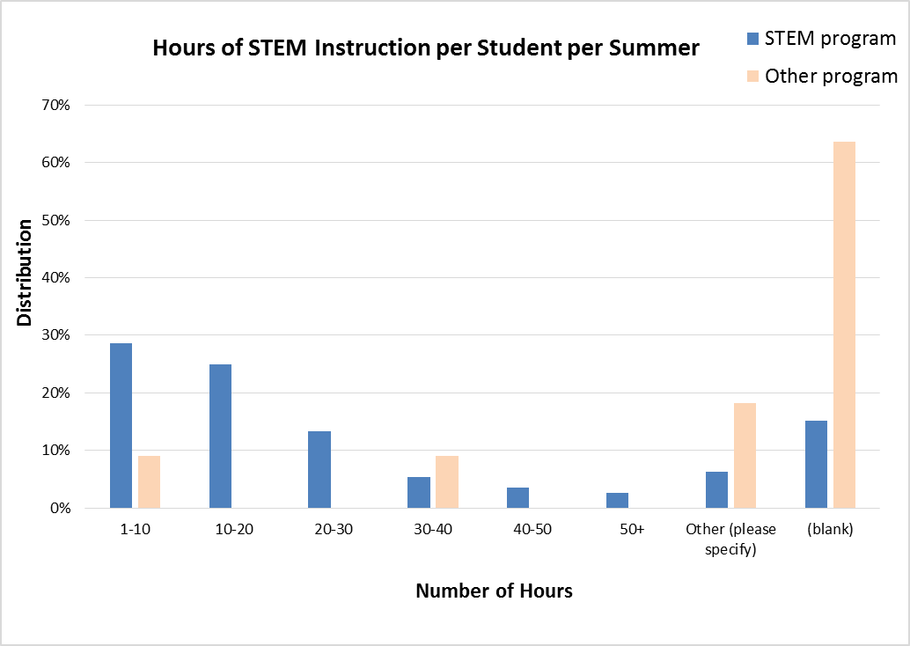
- Grades of youth reached through STEM offerings:
  - The number of students reached peaks in 3rd, 4th, and 5th grades. After the 5th grade, the number of youth reached declines.
  - Among the “other grades” responses, STEM programs indicate they reach preschool children.
  - Nine of the 11 Other programs indicated having a STEM offering for at least one grade. (This is derived from looking at raw data, not a pivot chart.)
Percents are of program total and do NOT sum to 100%. (programs may choose multiple responses)
GRADES REACHED | STEM program |  | Other program |  | All Programs
Grade | Count | Percent | Count | Percent | Count | Percent
Kindergarden | 69 | 62% | 3 | 27% | 72 | 59%
1st | 77 | 69% | 4 | 36% | 81 | 66%
2nd | 78 | 70% | 4 | 36% | 82 | 67%
3rd | 84 | 75% | 5 | 45% | 89 | 72%
4th | 87 | 78% | 5 | 45% | 92 | 75%
5th | 87 | 78% | 6 | 55% | 93 | 76%
6th | 75 | 67% | 3 | 27% | 78 | 63%
7th | 69 | 62% | 3 | 27% | 72 | 59%
8th | 69 | 62% | 3 | 27% | 72 | 59%
9th | 43 | 38% | 3 | 27% | 46 | 37%
10th | 41 | 37% | 2 | 18% | 43 | 35%
11th | 40 | 36% | 2 | 18% | 42 | 34%
12th | 39 | 35% | 2 | 18% | 41 | 33%
Other (please specify) | 17 | 15% | 3 | 27% | 20 | 16%
NUMBER OF PROGRAMS | 112 |  | 11 |  | 123

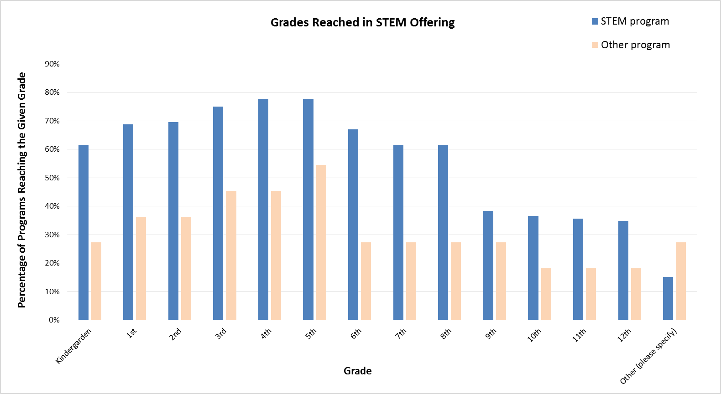

- Timing of STEM learning opportunities:
  - After school: 82% (92)
  - Summer: 79% (89)
  - Evenings: 30% (34)
  - Weekend: 26% (29)
  - Before school: 8% (22)
  - Other: 20% (22)
    - 4% (5) during school
    - 2% (2) during school breaks
    - 2% (2) during story time

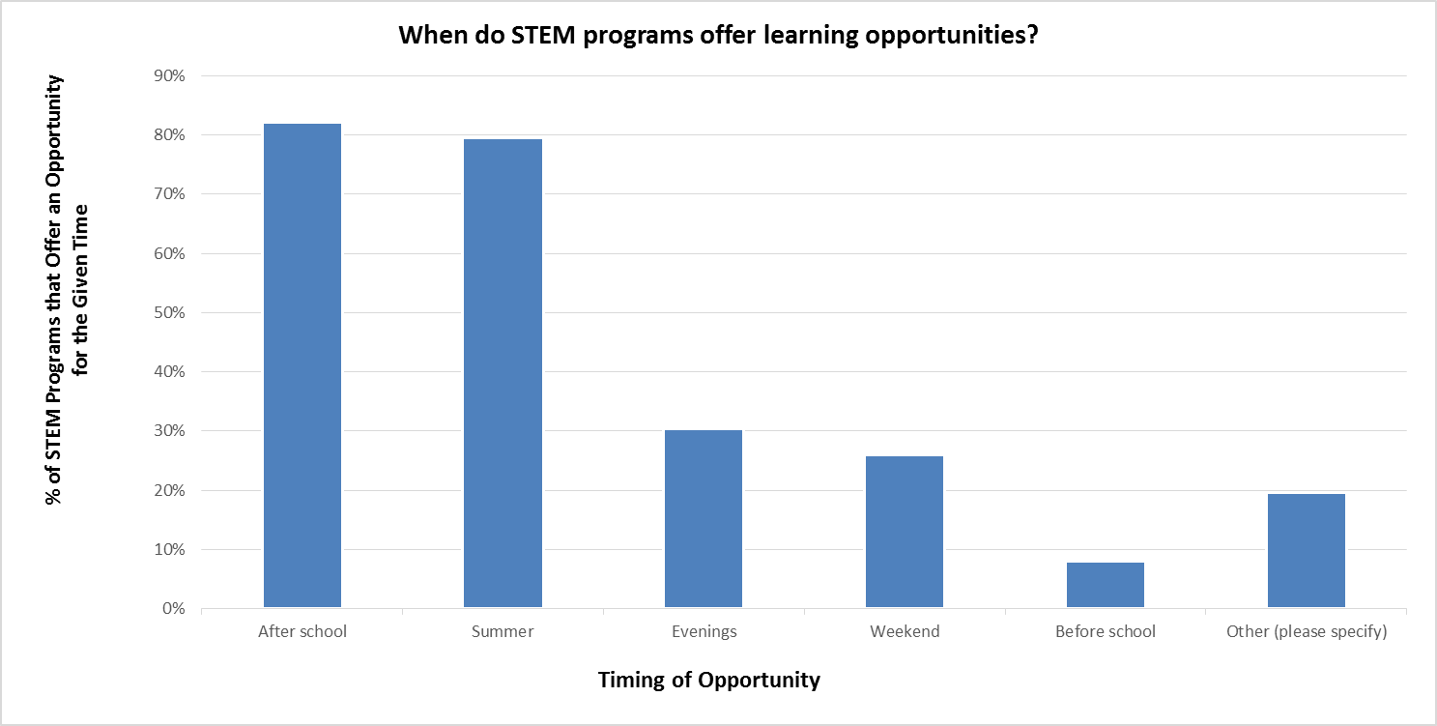

- Target demographics:
  - Females are the most prevalent target demographic; 66% (74) of STEM programs indicated this demographic.
  - Other demographics not specified included low income (2 STEM programs and 1 Other program), one mention of first generation, and one mention of refugees.
  - Demographics are targeted as follows:

Percents are of program total and do NOT sum to 100%. (programs may choose multiple responses)
TARGET DEMOGRAPHICS | STEM program |  | Other program |  | All Programs
Demographic | Count | Percent | Count | Percent | Count | Percent
Females | 74 | 66% | 1 | 9% | 75 | 61%
Rural populations | 72 | 64% | 2 | 18% | 74 | 60%
Males | 70 | 63% | 1 | 9% | 71 | 58%
Underrepresented ethnicities in STEM | 53 | 47% | 1 | 9% | 54 | 44%
Students with disabilities | 38 | 34% | 1 | 9% | 39 | 32%
English Language Learners (ELL) | 37 | 33% | 0 | 0% | 37 | 30%
Suburban populations | 23 | 21% | 1 | 9% | 24 | 20%
Urban populations | 21 | 19% | 1 | 9% | 22 | 18%
Other (please specify) | 17 | 15% | 2 | 18% | 19 | 15%
NUMBER OF PROGRAMS | 112 |  | 11 |  | 123

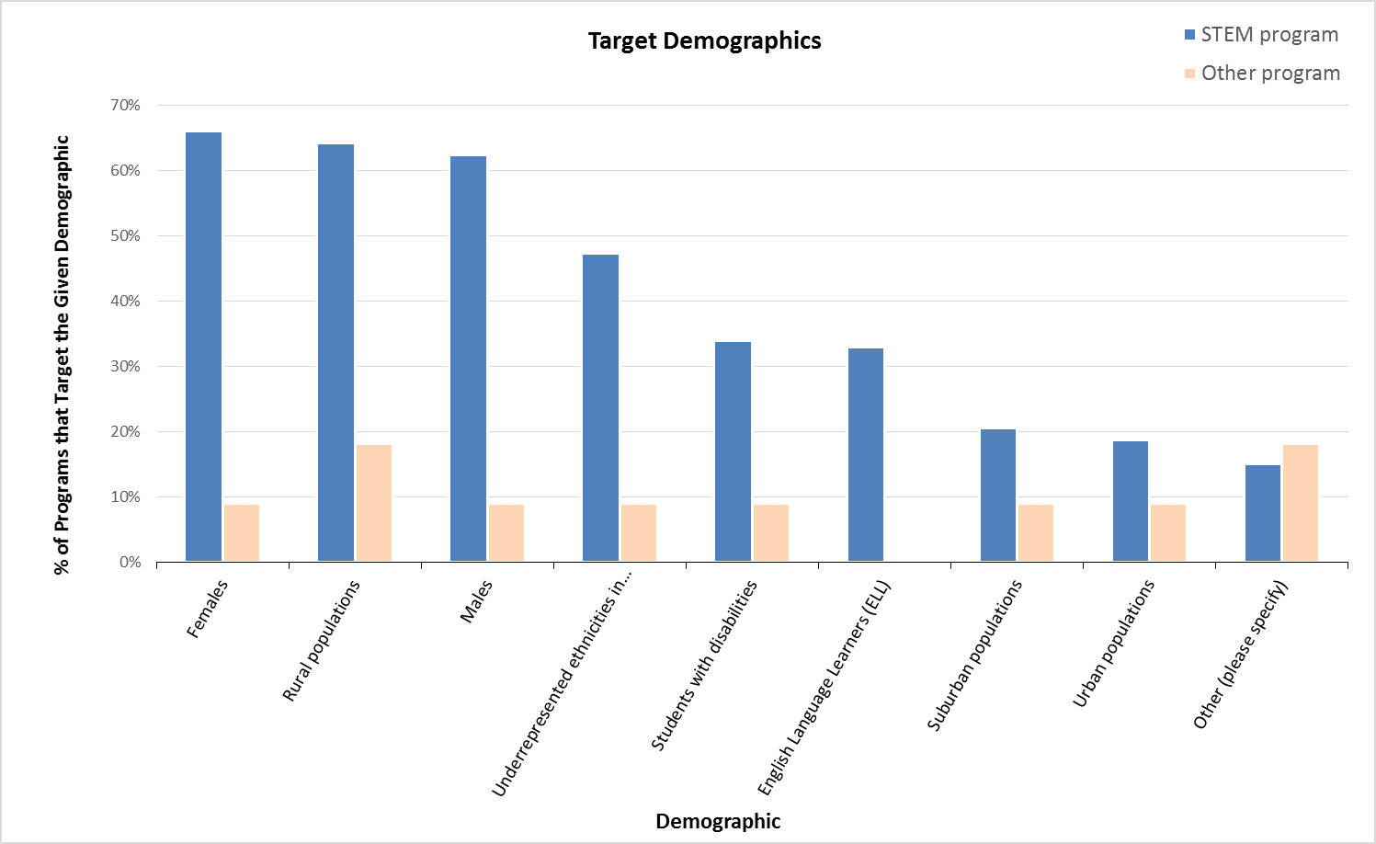

- Parent involvement:
  - 58% (65) of STEM programs report parent or family involvement.
  - Of these 65 programs:
    - 25% (16) have parents who regularly attend with the student.
    - 23% (15) receive volunteer assistance including mentoring and chaperoning.
    - 20% (13) have parent nights and/or family events.

CHALLENGES AND RESOURCES
- Of the 11 Other programs, they offered the following reason(s) for not currently offering STEM:
  - 73% (8) do not have funding for STEM curriculum
  - 55% (6) do not have qualified staff
  - 45% (5) Do not have time for a STEM program
  - 45% (5) do not know of an appropriate STEM curriculum
- Given 1 = greatest impact and 10 is the least impact (range was not specified in survey; is this assumption correct?), more money to purchase STEM curricula would have the greatest impact on programs’ likelihood of implementing STEM, followed by more time for STEM activities and more opportunities for staff to attend STEM trainings and workshops.

IMPACT OF RESOURCES ON STEM IMPLEMENTATION | STEM program |  | Other program |  | All Programs
Resource | Responses | Average Ranking* | Responses | Average Ranking* | Responses | Average Ranking*
More money to purchase STEM curricula | 108 | 4.11 | 1 | 1.00 | 109 | 4.08
More time for STEM activities | 102 | 4.44 | 1 | 2.00 | 103 | 4.42
More opportunities for staff to attend STEM trainings and workshops | 104 | 4.68 | 1 | 6.00 | 105 | 4.70
More time to study STEM | 100 | 5.24 | 1 | 3.00 | 101 | 5.22
More on-site STEM technical assistance | 102 | 5.47 | 1 | 7.00 | 103 | 5.49
More support from funders, supervisors and/or other stakeholders | 102 | 5.72 | 1 | 9.00 | 103 | 5.75
Better access to STEM experts | 103 | 5.84 | 1 | 5.00 | 104 | 5.84
More time to discuss STEM with colleagues | 102 | 5.90 | 2 | 6.50 | 104 | 5.91
Better access to online STEM resources | 98 | 6.13 | 1 | 4.00 | 99 | 6.11
Greater conviction that STEM is important to OST children/youth | 101 | 7.15 | 1 | 10.00 | 102 | 7.18
NUMBER OF PROGRAMS | 112 |  | 11 |  | 123
* Not all respondents ranked all options. 110 STEM program respondents and 2 Other program respondents ranked at least one resource.

Costs
- The costs of the STEM programs per student per year were grouped into the following dollar ranges. Some responses to this open-ended question did not fit in a single dollar range and are indicated with, “See text for explanation.” The original data may be referenced for the responses provided.
Percents roll up to column total and sum to 100%. (one response per program)
COST PER STUDENT PER YEAR | STEM program |  | Other program |  | All Programs
Cost Range | Count | Percent | Count | Percent | Count | Percent
$1 - $9 | 6 | 5% |  | 0% | 6 | 5%
$10 - $49 | 7 | 6% | 1 | 9% | 8 | 7%
$50 - $99 | 5 | 4% |  | 0% | 5 | 4%
$100 - $199 | 3 | 3% | 1 | 9% | 4 | 3%
$200 - $299 | 7 | 6% |  | 0% | 7 | 6%
$300 - $399 | 1 | 1% |  | 0% | 1 | 1%
$400 - $499 | 2 | 2% |  | 0% | 2 | 2%
$500 - $599 | 4 | 4% |  | 0% | 4 | 3%
$600 - $999 | 1 | 1% |  | 0% | 1 | 1%
$1,000 - $1,999 | 6 | 5% |  | 0% | 6 | 5%
$2,000 - $9,999 | 1 | 1% |  | 0% | 1 | 1%
$10,000 + | 1 | 1% |  | 0% | 1 | 1%
See text for explanation. | 20 | 18% |  | 0% | 20 | 16%
Unknown | 22 | 20% | 2 | 18% | 24 | 20%
(blank) | 26 | 23% | 7 | 64% | 33 | 27%
NUMBER OF PROGRAMS | 112 | 100% | 11 | 100% | 123 | 100%

Funding
- 49% (55) of STEM program respondents receive funding from the Idaho STEM Action Center. Only 19% (21) indicated they receive funding from parent/student fees. 6 (5%) respondents stated in the “other” option that they receive funding from the Idaho Commission for Libraries.

Percents are of program total and do NOT sum to 100%. (programs may choose multiple responses)
STEM PROGRAM FUNDING SOURCES | STEM program |  | Other program |  | All Programs
Funding Source | Count | Percent | Count | Percent | Count | Percent
Idaho STEM Action Center | 55 | 49% | 1 | 9% | 56 | 46%
Private philanthropic foundation/private grants | 30 | 27% | 1 | 9% | 31 | 25%
Department of Education's 21st Century Community Learning Centers (21stCCLC) | 29 | 26% | 0 | 0% | 29 | 24%
Individual gifts | 29 | 26% | 3 | 27% | 32 | 26%
Business/corporation sponsorships | 26 | 23% | 1 | 9% | 27 | 22%
Fundraisers | 25 | 22% | 0 | 0% | 25 | 20%
State or city government funding stream | 24 | 21% | 0 | 0% | 24 | 20%
Parent/student fees | 21 | 19% | 0 | 0% | 21 | 17%
Other federal funding (ex., NSF, NASA, Department of Defense, etc.) | 15 | 13% | 0 | 0% | 15 | 12%
School or school district | 15 | 13% | 2 | 18% | 17 | 14%
Child Care Development Fund | 1 | 1% | 0 | 0% | 1 | 1%
Other (please specify) | 22 | 20% | 1 | 9% | 23 | 19%
NUMBER OF PROGRAMS | 112 |  | 11 |  | 123

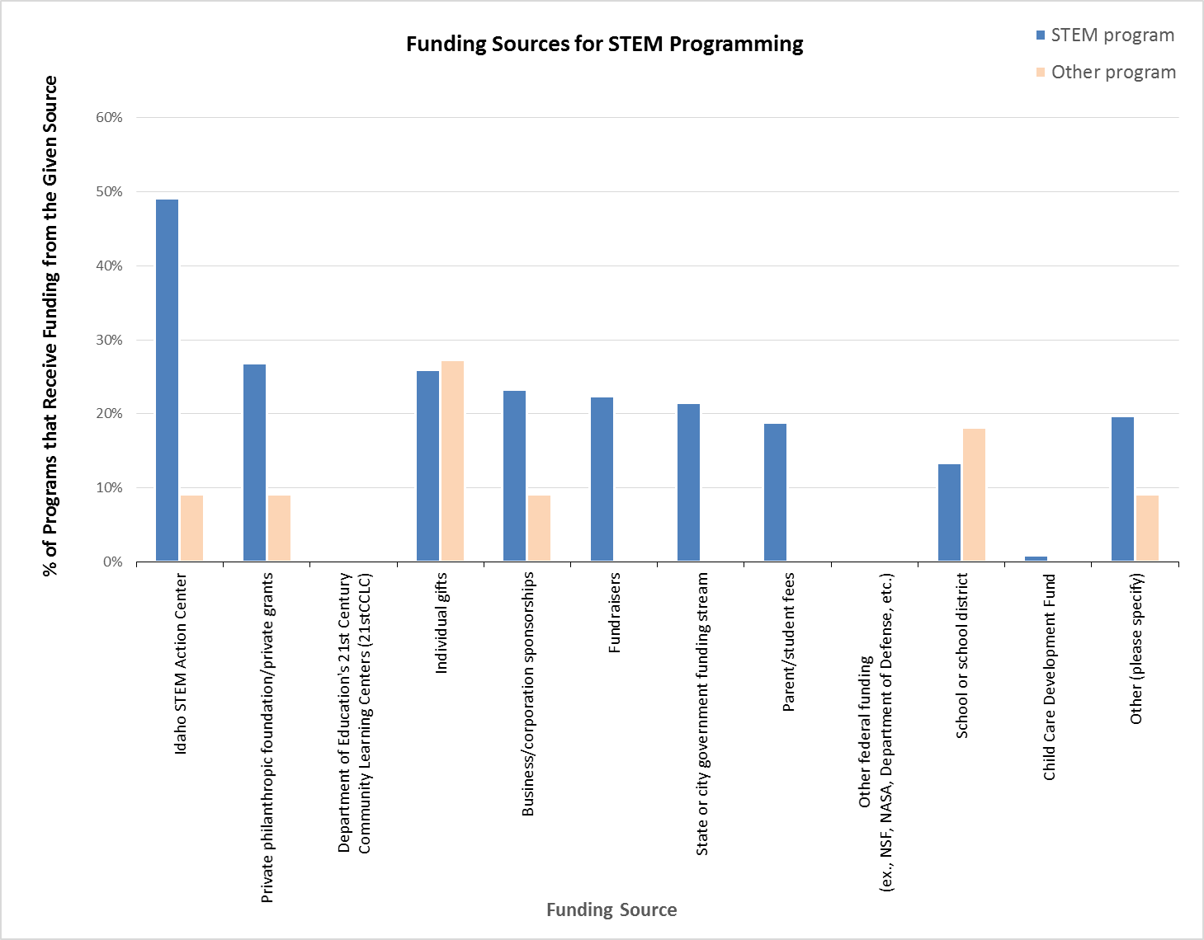
- 16% (18) of STEM program respondents charge fees to participate; 64% (72) do not. 7% (8) gave an “other” response with elaborating text; 13% (14) did not answer this question.
  - Open-ended responses to the question of how much the family or student pays to participate follow:
    - $100 per year and the child/family is asked to help fundraise another $300.
    - $12
    - $12 per day
    - $15
    - $250 for e-Camp; e-Girls is free
    - $45/month but that includes all after school activities like transportation to the club and snack and care after the program
    - $5 per visit (open studio), $10 for after school program, $15 to $25 per day for workshops and day camps.
    - $6.00 per day, $4.00 per day or $3.00 per day depending on free and reduced lunch status. After school preschool is $2.50 per hour
    - 25.00 for punch card with 5 visits
    - around $5/hr
    - Depends- anywhere from 0 to $100
    - Depends if they are a Y member or not. Monthly $160 for non members and $128 for non members.
    - Our adult classes will occasionally have a $3 materials fee.
    - See above --->$10
    - The cost per program is $100. Each program lasts 4 weeks.
    - There is a yearly membership fee for Girl Scouts, and then activities range from being free to a 1 week resident camp of a $365. Most activities are under $10.
    - Tier 1 - $410 Tier 2 - $475 Tier 3 - $535
    - Typically $20/day for something like a 2-3 day summer camp on aviation careers.
    - Varies (3 responses)
    - Varies - ranges from $99-225
- The following table shows the intersection of STEM program funding sources and whether programs charge fees.
Percents are of total responses received for each funding source and sum to 100% across rows.
STEM PROGRAM FUNDING SOURCES  BY FEES CHARGED | YES - fees charged |  | NO - fees not charged |  | Other Response |  | Total Responses for Funding Source
Funding Source | Count | Percent | Count | Percent | Count | Percent | Count | Percent
Idaho STEM Action Center | 6 | 11% | 45 | 82% | 4 | 7% | 55 | 100%
Private philanthropic foundation/private grants | 10 | 33% | 17 | 57% | 3 | 10% | 30 | 100%
Department of Education's 21st Century Community Learning Centers (21stCCLC) | 1 | 3% | 26 | 90% | 2 | 7% | 29 | 100%
Individual gifts | 6 | 21% | 20 | 69% | 3 | 10% | 29 | 100%
Business/corporation sponsorships | 8 | 31% | 16 | 62% | 2 | 8% | 26 | 100%
Fundraisers | 9 | 36% | 14 | 56% | 2 | 8% | 25 | 100%
State or city government funding stream | 3 | 13% | 19 | 79% | 2 | 8% | 24 | 100%
Parent/student fees | 15 | 71% | 0 | 0% | 6 | 29% | 21 | 100%
Other federal funding (ex., NSF, NASA, Department of Defense, etc.) | 2 | 13% | 11 | 73% | 2 | 13% | 15 | 100%
School or school district | 1 | 7% | 10 | 67% | 4 | 27% | 15 | 100%
Child Care Development Fund | 0 | 0% | 0 | 0% | 1 | 100% | 1 | 100%
Other (please specify) | 1 | 5% | 19 | 86% | 2 | 9% | 22 | 100%

Scholarships
- 21% (23) of STEM program respondents have means to provide scholarships; 51% (57) do not.
- Descriptions of available scholarships follow:
  - 4-H provides opportunities for all youth. IF money is an issue and parents ask we try to figure out how to make it happen
  - Application process to receive a 1/3 scholarship to a week long STEAM camp session
  - can talk to director for a scholarships
  - Each Club has a scholarship fund for the school year
  - e-Camp scholarships provided based on need
  - Families apply for scholarship with our Welcome Center. Each family is given a rate that best fits their needs.
  - FastForward funds
  - partial and full camp scholarships and field trip scholarships. All are needs-based. our rural outreach program is offered at no cost to schools due to grant support.
  - Scholarship program starting Fall 2018
  - Scholarships already included for certain camps sponsored by the STEM AC
  - sliding fee scale for lower income
  - The $12 fee can be scholarshiped. We have local businesses that pay the fee when needed for youth to participate.
  - Through community, state, and national organizations.
  - Through our partnerships.
  - We are ICCP certified and we provide scholarships to families who need help we don’t turn anyone away because of the inability to pay
  - we have an internal scholarship program
  - We have currenltly $340+ available in scholarships, donated by ICCU, Battelle Energy Alliance, and Bingham Memorial Hospital.
  - We have financial assistance for activities and camps.
  - We offer scholarships for different activities and programs, depending on available funding.
  - We often look for sources that can provide funds used for scholarships. For example, AAUW.
  - We will always scholarship our general membership at parent request, although the programs themselves for STEM are free. this does ensure open and equal access to all Club Members.
  - We work with families to help offset fees. I won't turn a child away.

Partnerships
- 71% (79) of responding STEM programs involve partners.
  - NOTE: 8 respondents answered “No” to the question of whether partners are involved but also checked at least one partner in the subsequent question about which partners are engaged in their STEM program. Therefore, all 112 STEM programs are used in calculation of percentages in the following table.
Percents are of program total and do NOT sum to 100%. (programs may choose multiple responses)
PARTNERS ENGAGED IN PROGRAMMING | STEM program |  | Other program |  | All Programs
Partner | Count | Percent | Count | Percent | Count | Percent
Librarians | 49 | 44% | 2 | 18% | 51 | 41%
STEM professionals (those working in a STEM career) | 41 | 37% | 0 | 0% | 41 | 33%
4-H Extension | 35 | 31% | 1 | 9% | 36 | 29%
College or university | 32 | 29% | 0 | 0% | 32 | 26%
School STEM teachers | 29 | 26% | 1 | 9% | 30 | 24%
Business/corporations | 28 | 25% | 1 | 9% | 29 | 24%
State Agency (Department of Ed, Health & Welfare, STEM Action Center) | 28 | 25% | 0 | 0% | 28 | 23%
Science center or museum | 23 | 21% | 0 | 0% | 23 | 19%
Other (please specify) | 18 | 16% | 2 | 18% | 20 | 16%
Federal Science Agency (NASA, NIH, etc.) | 13 | 12% | 0 | 0% | 13 | 11%
NUMBER OF PROGRAMS | 112 |  | 11 |  | 123
- The most common resource provided by the partners is volunteers as indicated by 54% (60) of STEM program respondents. 48% (54) of STEM program respondents receive materials from their partners.

Percents are of program total and do NOT sum to 100%. (programs may choose multiple responses)
RESOURCES PROVIDED BY PARTNERS | STEM program |  | Other program |  | All Programs
Resource | Count | Percent | Count | Percent | Count | Percent
Volunteers | 60 | 54% | 1 | 9% | 61 | 50%
Materials | 54 | 48% | 1 | 9% | 55 | 45%
Funding | 47 | 42% | 1 | 9% | 48 | 39%
Expertise | 45 | 40% | 0 | 0% | 45 | 37%
Curriculum | 34 | 30% | 0 | 0% | 34 | 28%
Training | 25 | 22% | 0 | 0% | 25 | 20%
Advocacy | 23 | 21% | 1 | 9% | 24 | 20%
Other (please specify) | 8 | 7% | 3 | 27% | 11 | 9%
NUMBER OF PROGRAMS | 112 |  | 11 |  | 123

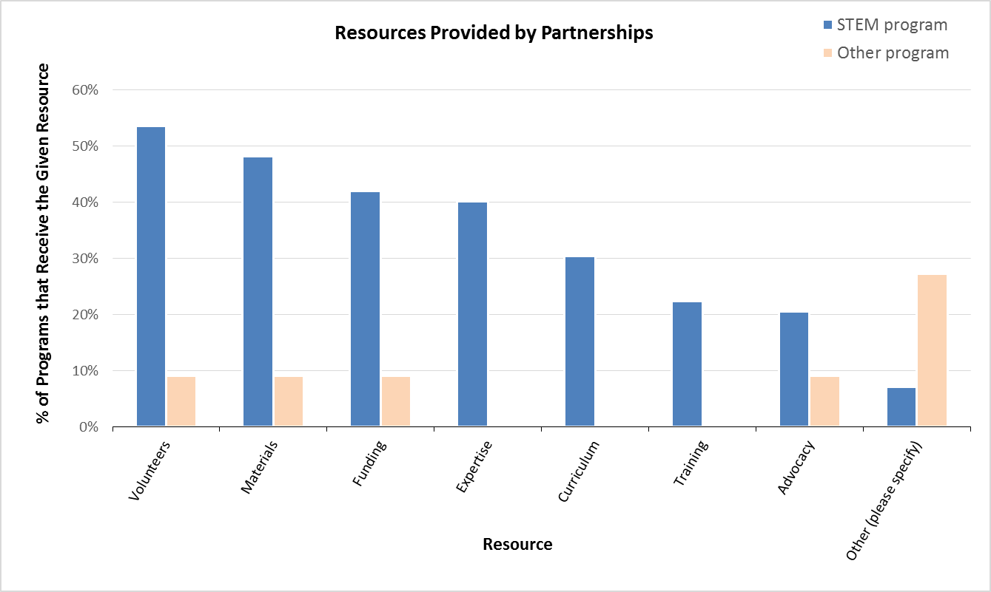

CURRICULUM
- 19% (21) of STEM program respondents answered “Yes” to offering the same STEM curriculum and multiple STEM sites; 37% (41) answered “No.” 45% (50) did not answer this question.
- The most cited goal (82%, 92) of STEM program respondents is for youth to develop interest in STEM activities. “Youth demonstrate problem-solving skills” was the second most cited goal for STEM programs (77%, 86) and the most cited goal of Other program respondents (36%, 3).
Percents are of program total and do NOT sum to 100%. (programs may choose multiple responses)
PROGRAM GOALS | STEM program |  | Other program |  | All Programs
Goal | Count | Percent | Count | Percent | Count | Percent
Youth develop interest in STEM activities | 92 | 82% | 3 | 27% | 95 | 77%
Youth demonstrate problem-solving skills | 86 | 77% | 4 | 36% | 90 | 73%
Youth develop STEM knowledge | 82 | 73% | 1 | 9% | 83 | 67%
Youth strengthen abilities to work as a team | 81 | 72% | 2 | 18% | 83 | 67%
Youth develop STEM skills | 79 | 71% | 2 | 18% | 81 | 66%
Youth develop an understanding of relevance of STEM to everyday life | 78 | 70% | 2 | 18% | 80 | 65%
Youth develop positive self image towards STEM | 72 | 64% | 2 | 18% | 74 | 60%
Youth improve academic performance in STEM areas | 60 | 54% | 3 | 27% | 63 | 51%
Youth develop an understanding of STEM careers | 58 | 52% | 0 | 0% | 58 | 47%
NUMBER OF PROGRAMS | 112 |  | 11 |  | 123
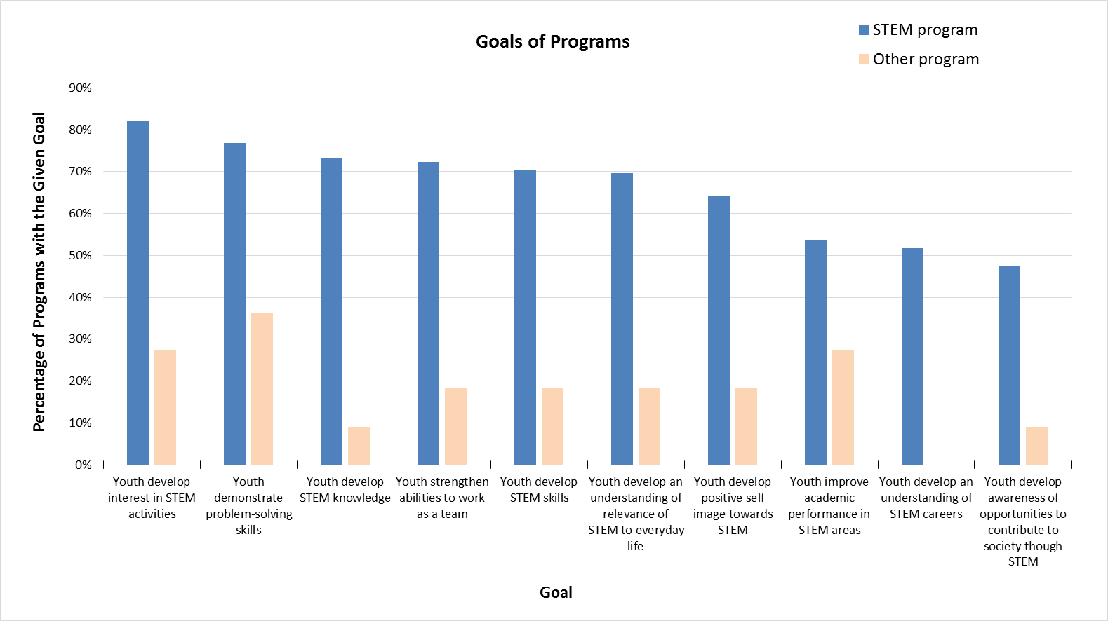
- The breakdown on the aspects of STEM that the STEM programs focus on are as follows. Respondents were able to select more than one option; the percentages are of the 112 STEM program respondents.
  - Mostly science: 61% (68 respondents)
  - Mostly technology: 46% (52)
  - Mostly engineering: 43% (48)
  - Mostly math: 19% (21)
  - Other: 13% (15)
    - 8 of the “Other” responses indicate they include Art as a component.
- Over half (53%, 39) of the STEM programs often integrate the disciplines with one another.
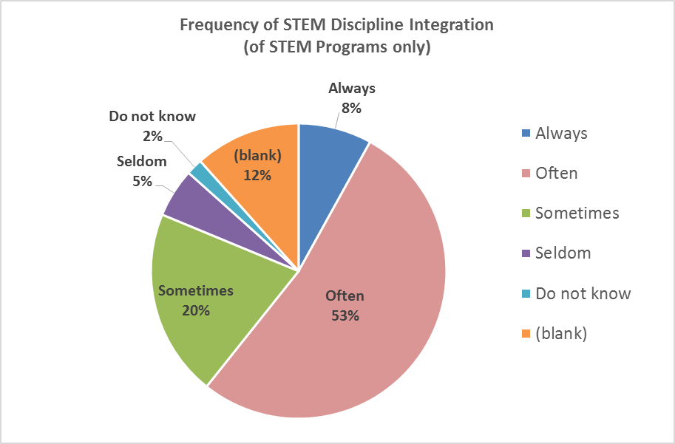

- 50% (56) of STEM program respondents use STEM curricula, toolkits, or lesson plans developed in-house. 51% (57) use a combination of in-house and other resources.
Percents are of program total and do NOT sum to 100%. (programs may choose multiple responses)
TYPE OF STEM CURRICULA TOOLKITS, OR LESSON PLANS | STEM program |  | Other program |  | All Programs
Type | Count | Percent | Count | Percent | Count | Percent
Developed in-house | 56 | 50% | 3 | 27% | 59 | 48%
Developed outside of organization (free to use) | 25 | 22% | 3 | 27% | 28 | 23%
Developed outside of organization (cost to use) | 14 | 13% | 0 | 0% | 14 | 11%
Combination | 57 | 51% | 1 | 9% | 58 | 47%
Other (please specify) | 4 | 4% | 0 | 0% | 4 | 3%
NUMBER OF PROGRAMS | 112 |  | 11 |  | 123
- Open-ended responses to the sources of outside curricula for the STEM programs are listed below.
  - 21st Century Grant
  - American Association of Physics Teachers, American Chemical Society, American Physical Society, Natonal Science Teachers Association, National Association of Biology Teachers, Science Olympiad, National Society of Professional Engineers, plus others.
  - Birdsleuth, plus adapting math lessons to fit bird theme
  - Boise State University provides curriculum for after school STEM Club
  - Breakout EDU, $125
  - BreakoutEDU, Pinterest.
  - Civil Air Patrol Educator - free materials with paid membership
  - click2science, code.org, kahn academy, stem action center
  - Click2Science, Stemfinity, Steve Splangler
  - code.org (2 responses)
  - Code.org, Scratch, Tynker, Khan Academy, etc
  - Code.org; Google; Common Sense
  - Crazy Eights Bedtime Math, Brick Lab Survey, Steve Spangler Science
  - Cubelets, Finch robotics, Engineering for Kids, etc.
  - deer flat national wildlife refuge, hunters edu. online sites, nun, h.p, micron, 4-h
  - Earth to Sky, NPS, USGS
  - FIRST Lego League, unsure of other resources the program teacher uses
  - FIRST Robotics
  - Gizmo CDA
  - I don't use formal curricula
  - Id STEM action center, STEMfinity, Paralax
  - Idaho National Labratory
  - Idaho Public TV- Coding
  - Idaho Robotics, Building Blocks
  - Idaho STEM Action Center
  - ideas found various places on the internet
  - INL, STEM Access center
  - internet
  - Internet, 4H, Girlsmart, How to Smile, You4Youth, Zoom and other programs chosen by Site coordinators
  - Junior Master Gardening, 4H, Modern Woodsman etc
  - KaBoom (Comm Lib Network)
  - Kahn Academy, public library, and Stemfinity
  - Kiwi Crate kits and project kits from S&S Worldwide
  - Lego Robotics, 3-D Fab-Lab,
  - Makey Makey
  - materials available from Latah County Library District of which Deary Library is one of its branches
  - Micron Foundation
  - National 4-H Curriculum
  - Paralax, ION, Afterschool Alliance, You 4 Youth
  - PCS Edventures
  - Pinterest (2 responses)
  - robotics, 4H
  - schools
  - see above
  - STEM AC
  - STEM Clearinghouse
  - Stem in libraries
  - Stemfinity, EIE kits
  - The Meridian Public Library has Stem Kits available to check out
  - Tinker crates
  - U of I Extension, County 4-H
  - Upstart and a variety of online sites
  - UUAH, Inc. and PCS Edventures are two key providers.
  - We Do Lego Robotics, Estes
  - We have worked with 4-H curriculum, the BLM, and Project Learning Tree.
  - We regularly bring in outside organizations to put on programs such as BSU, Citizen Scientific Workshop, STEMstitute, and other local professional organizations
  - We work with private contracts to develop program-specific content and also adapt many of our curricula from open source platforms such as code.org, pinterest, etc.
  - Y-USA and online resources
- 14% (16) of STEM programs have established curricula or programs available for use by other afterschool providers.
- STEM programs provide their programming in the following formats. Respondents selected only one response.
  - Lessons or individual activities offered periodically: 33% (37)
  - Stand-alone STEM afterschool program: 30% (34)
  - Multiple electives within comprehensive afterschool program: 14% (16)
  - Elective within comprehensive afterschool program: 2% (2)
  - None of the above selected: 21% (23)
    - 8 respondents who did not make a selection supplied the following in the “Other” open-response field:
      - At lunch
      - Camps
      - Nationals creates a curriculum and our staff follow that as a guide
      - One week summer camp experience based around STEAM programming
      - Storytimes and afterschool programs
      - Tutoring during the academic year; immersive, hands-on experiences during the summer as part of an integrated omnibus curriculum focused around career interests (i.e., healthcare, business, environmental science, teaching, etc.)
      - two summer camps
      - varies with the need. We provide for a comprehensive after school program, as well as one-time events
      - via storytime and summer reading programs
      - What ever works and we have the resources to support
- Typical length of STEM learning experiences are as follows:

Percents are of program total and do NOT sum to 100%. (programs may choose multiple responses)
LENGTH OF STEM LEARNING EXPERIENCES | STEM program |  | Other program |  | All Programs
Duration | Count | Percent | Count | Percent | Count | Percent
15 minutes | 3 | 3% |  | 0% | 3 | 2%
30 minutes | 9 | 8% | 2 | 18% | 11 | 9%
45 minutes | 20 | 18% |  | 0% | 20 | 16%
1 hour | 38 | 34% |  | 0% | 38 | 31%
1.5 hours | 11 | 10% | 1 | 9% | 12 | 10%
2 hours | 7 | 6% |  | 0% | 7 | 6%
2.5 hours | 1 | 1% |  | 0% | 1 | 1%
4 hours | 2 | 2% |  | 0% | 2 | 2%
Other (please specify) | 9 | 8% | 1 | 9% | 10 | 8%
(blank) | 12 | 11% | 7 | 64% | 19 | 15%
bNUMBER OF PROGRAMS | 112 |  | 11 |  | 123
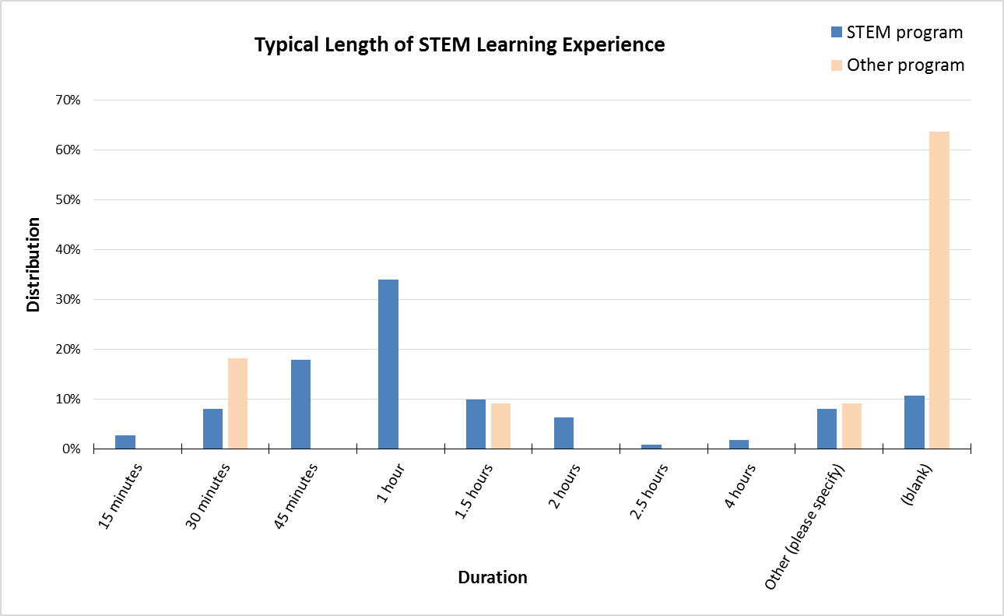

STANDARDS
- 29% (33) of STEM program respondents utilize state or national core education STEM standards; 20% (22) do not. 35% (39) are unsure whether formal standards are used. 4% (5) gave an “other” response.
- The following table indicates the standards programs are using.
Percents are of program total and do NOT sum to 100%. (programs may choose multiple responses)
STANDARDS UTILIZED | STEM program |  | Other program |  | All Programs
Standard | Count | Percent | Count | Percent | Count | Percent
State Standards | 35 | 31% | 2 | 18% | 37 | 30%
Common Core Math | 13 | 12% | 2 | 18% | 15 | 12%
Common Core English Language Arts | 11 | 10% | 2 | 18% | 13 | 11%
Nest Generation Science Standards (NGSS) | 16 | 14% | 1 | 9% | 17 | 14%
Computer Science Teachers Association (CSTA) | 4 | 4% | 0 | 0% | 4 | 3%
K-12 Computer Science Standards | 8 | 7% | 0 | 0% | 8 | 7%
Other: Unsure | 6 | 5% | 0 | 0% | 6 | 5%
NUMBER OF PROGRAMS | 112 |  | 11 |  | 123
- Of the STEM programs that answered “no,” “unsure,” and “other” to the question of whether they use standards, 39 provided a reason why standards are not utilized. The open-ended responses were categorized for analysis. Percentages in the following table are a distribution of the 39 open-ended responses, not the 112 STEM programs.
Percents roll up to column total and sum to 100%. (one response per program)
REASONS STANDARDS NOT UTILIZED | STEM program
Reason | Count | Percent
Not aware of or little knowledge of standards | 12 | 31%
Not required / not formal education | 5 | 13%
Offer opportunities outside of school curriculum | 3 | 8%
Lack of time or resources | 3 | 8%
Standards are too difficult to implement | 2 | 5%
Some but not all activities use standards | 2 | 5%
Informal standards used | 2 | 5%
Unknown | 2 | 5%
STEM is not the focus | 1 | 3%
Standards not needed | 1 | 3%
Standards change too frequently | 1 | 3%
Idaho standards are sub par | 1 | 3%
Use what is available | 1 | 3%
Not a teacher | 1 | 3%
Does not focus on specific goal or standard | 1 | 3%
Did not occur to use standards | 1 | 3%
NUMBER OF RESPONSES | 39 | 100%

PROFESSIONAL DEVELOPMENT
- Almost half (49%, 55) of the STEM program respondents use an “other paid instructor” as a STEM instruction provider. All provider types are listed in the following table.
  - 19 (17% of all STEM programs) of the “Other” responses mentioned either a librarian or library staff.
Percents are of program total and do NOT sum to 100%. (programs may choose multiple responses)
STEM INSTRUCTION PROVIDERS | STEM program |  | Other program |  | All Programs
Provider | Count | Percent | Count | Percent | Count | Percent
Other paid instructor | 55 | 49% | 0 | 0% | 55 | 45%
School-day teacher (paid) | 33 | 29% | 1 | 9% | 34 | 28%
Community member (volunteer) | 33 | 29% | 2 | 18% | 35 | 28%
Unpaid instructor (volunteer) | 30 | 27% | 0 | 0% | 30 | 24%
STEM professional (volunteer) | 23 | 21% | 0 | 0% | 23 | 19%
STEM professional (paid) | 19 | 17% | 0 | 0% | 19 | 15%
Peer (student) | 15 | 13% | 0 | 0% | 15 | 12%
School-day teacher (volunteer) | 12 | 11% | 0 | 0% | 12 | 10%
Other (please specify) | 30 | 27% | 2 | 18% | 32 | 26%
NUMBER OF PROGRAMS | 112 |  | 11 |  | 123

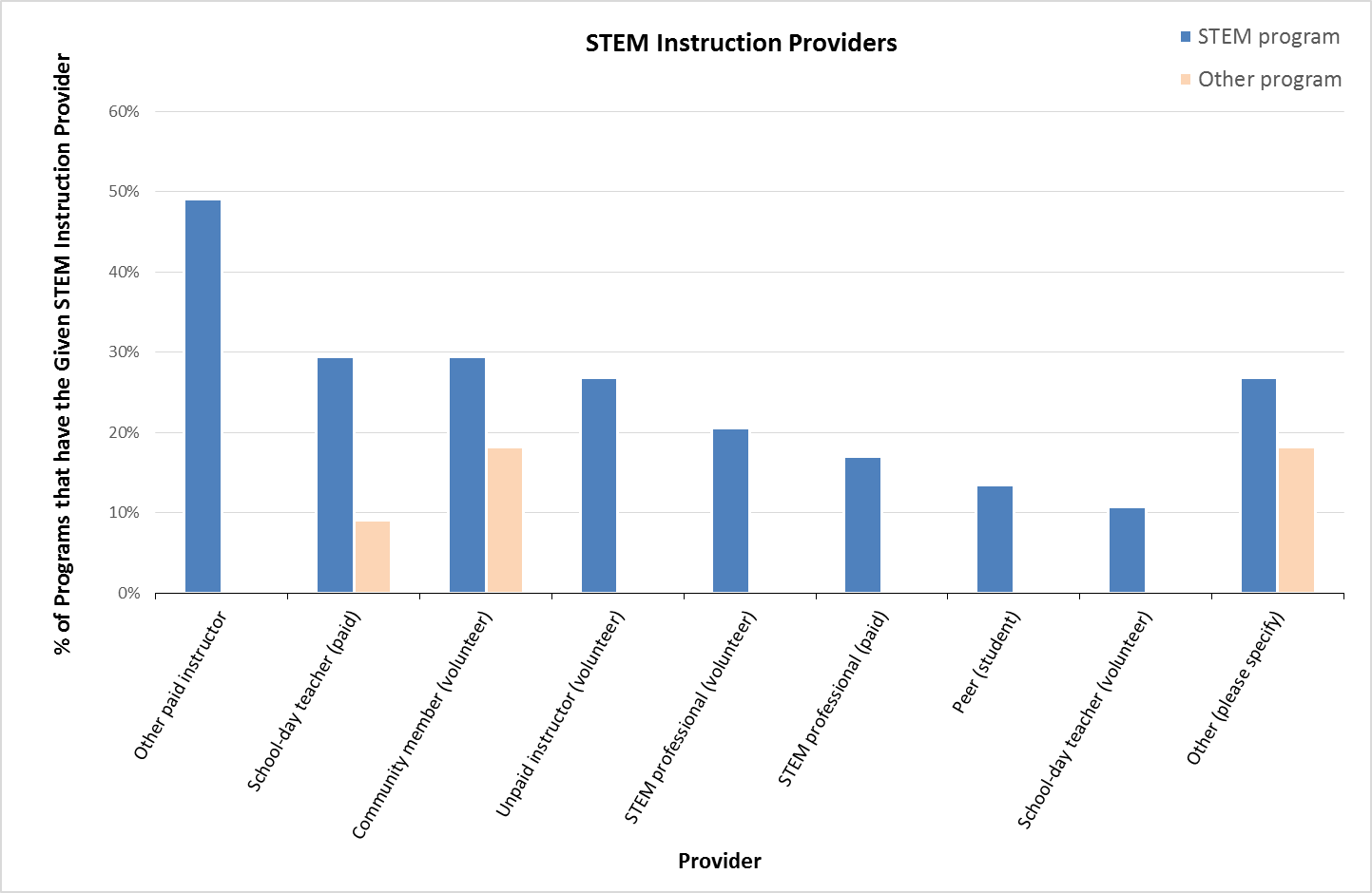
- STEM professionals are utilized in several capacities as indicated in the following table.
Percents are of program total and do NOT sum to 100%. (programs may choose multiple responses)
STEM PROFESSIONAL ROLES | STEM program |  | Other program |  | All Programs
Role | Count | Percent | Count | Percent | Count | Percent
Lead teaching | 31 | 28% | 0 | 0% | 31 | 25%
Mentoring | 24 | 21% | 1 | 9% | 25 | 20%
Workplace visits/tours | 20 | 18% | 0 | 0% | 20 | 16%
Co-teaching | 19 | 17% | 0 | 0% | 19 | 15%
Curriculum development | 16 | 14% | 0 | 0% | 16 | 13%
Classroom support | 15 | 13% | 0 | 0% | 15 | 12%
Other (please specify) | 14 | 13% | 1 | 9% | 15 | 12%
NUMBER OF PROGRAMS | 112 |  | 11 |  | 123
- 43% (48) of STEM program respondents provide training or professional development for STEM instructors; 40% (45) do not. 17% (19) did not answer this question.
- The following lists the open-ended responses regarding type of training from STEM programs. Some who do not provide training supplied a response as well.
  - YES – training provided:
    - A minimum of 20 hours of formal training
    - Annual training through district.
    - as possible - workshops, conferences, webinars...
    - By Mentor
    - Click2Science
    - click3science
    - District PD includes STEM instructors; special opportunities provided by STEM Action of Idaho, etc., are always appreciated and accessed when possible.
    - FIRST, 4-H
    - From local STEM PD and our STEM Coordinator.
    - Grant gained teaching
    - I look for webinars and seminars offered by outside institutions, ICFL, iSTEM, etc. The library pays any fees.
    - I offer a handful of workshops per year for Troop leaders, but I wish we had more training available for them.
    - ICfL, STEM AC, and ION training
    - Idaho Commission for Libraries - online webinars
    - information from workshops other staff have attended
    - In-house training on STEM subject matter and youth development
    - NPS
    - Online resources, past experience, training in the field, PD offered by sources online or as a class
    - Only if we get grants to pay for them to get the instructions.
    - PD is provided by 21st Century Director
    - SOMETIMES. It depends on what we are teaching.
    - STEM Action Center training in Salmon, other online options
    - STEM class will be in June
    - STEM workshops and online training classes have been provided.
    - Training is provided by the Afterschool Program with funds to attend professional development opportunities locally and also through Click2Science online training.
    - UI Extension Staff
    - University of Idaho requires several trainings as condition of employment when working with minors
    - we are able to attend the idaho out of school conference and other conferences and click 2 science
    - We have many levels of training for our staff and volunteers.
    - We offer different types of training.
    - We train facilitators in-house through guidebooks, train-the-trainer videos, and/or in-person train-the-trainer sessions.
    - We utilize the Code.org curriculum plus additional curriculum that we have developed in-house
    - Webinars
    - Webinars, workshops, and other library training sessions that are children and STEM focused
    - Yes and No. We do in house training and share resources.
    - Yes, through the ICFL for preschool-age children.
  - NO – training not provided:
    - I will attend training and professional development programs when they are offered at a good time and are free. Our library does not have a large budget.
    - must be taken on own
    - Not currently or ongoing but occasionally.
    - Not enough time
    - our program does offer PD, but not necessarily based on STEM. However, 2 of our staff members were able to attend Click2Science training & really had success in sharing with our staff.
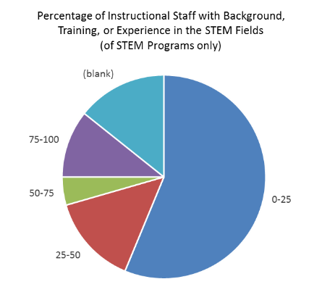
- Over half (56%, 63) of STEM program respondents estimate 0% - 25% of their instructional staff have a background, training, or experience in STEM fields. 18% (20) estimate 75% - 100% of instructional staff have expressed an interest in STEM fields.
Percents roll up to column total and sum to 100%. (one response per program)
ESTIMATE OF % OF STAFF WITH STEM BACKGROUND | STEM program |  | Other program |  | All Programs
Estimated Percentage | Count | Percent | Count | Percent | Count | Percent
0-25 | 63 | 56% | 3 | 27% | 66 | 54%
25-50 | 16 | 14% | 1 | 9% | 17 | 14%
50-75 | 5 | 4% |  | 0% | 5 | 4%
75-100 | 12 | 11% |  | 0% | 12 | 10%
(blank) | 16 | 14% | 7 | 64% | 23 | 19%
NUMBER OF PROGRAMS | 112 | 100% | 11 | 100% | 123 | 100%
Percents roll up to column total and sum to 100%. (one response per program)
ESTIMATE OF % OF STAFF WITH INTEREST IN STEM | STEM program |  | Other program |  | All Programs
Estimated Percentage | Count | Percent | Count | Percent | Count | Percent
0-25 | 48 | 43% | 3 | 27% | 51 | 41%
25-50 | 15 | 13% |  | 0% | 15 | 12%
50-75 | 14 | 13% |  | 0% | 14 | 11%
75-100 | 20 | 18% | 1 | 9% | 21 | 17%
(blank) | 15 | 13% | 7 | 64% | 22 | 18%
NUMBER OF PROGRAMS | 112 | 100% | 11 | 100% | 123 | 100%
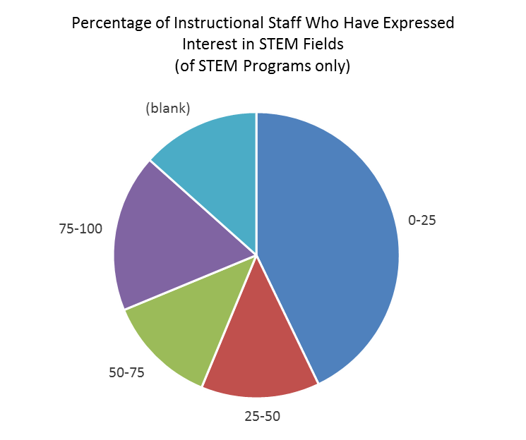

- Once a year is the most common (38%, 43) frequency of staff participation in STEM-related workshops and trainings, followed by less than once a year (32%, 36).
Percents roll up to column total and sum to 100%. (one response per program)
FREQUENCY OF STAFF STEM TRAINING | STEM program |  | Other program |  | All Programs
Frequency | Count | Percent | Count | Percent | Count | Percent
$1 - $9 | 6 | 5% |  | 0% | 6 | 5%
Once a month | 1 | 1% |  | 0% | 1 | 1%
6 times a year | 2 | 2% |  | 0% | 2 | 2%
4 times a year | 14 | 13% |  | 0% | 14 | 11%
Once a year | 43 | 38% | 2 | 18% | 45 | 37%
Less than once a year | 36 | 32% | 2 | 18% | 38 | 31%
(blank) | 16 | 14% | 7 | 64% | 23 | 19%
NUMBER OF PROGRAMS | 112 | 100% | 11 | 100% | 123 | 100%

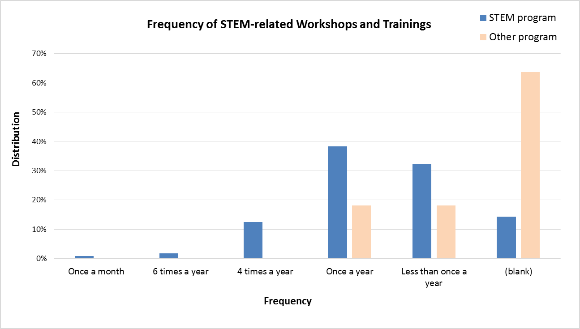
- STEM program respondents specified their current professional development needs; their open-ended responses follow.
  - $$$$$$$$$$$$
  - all of us are scientists with very little formal education training. We are good teachers, but don't have any background to inform us what type of lessons/curriculum are most useful to teachers
  - An overall introduction to coding would be great!
  - Basic technology.
  - Basic training for implementing STEM programs
  - Coding and robotics
  - Computer science k-4, makey makey invention literacy workshop for educators, robotics or k-3 grades
  - connection with STEM resources in North Idaho (I am new here) Networking opportunities
  - Curriculum development, program supplies, goals and objectives, and funding
  - Free stem training to boost skills
  - Furthering education and knowledge to learn how to teach subject-area content and concepts more effectively, learn classroom management techniques, improve teaching effectiveness and student performance.
  - Helping youth interest in STEM learning & career fields, learning for self and teaching STEM.
  - High need of staff development but needs to be online and free.
  - High quality STEM PD
  - how to use the STEM standards
  - I would love to learn more about STEM so I can pass on what I learn to our students. I get a lot of our activities from ideas on Pintrest
  - I'd like to see my 21st CCLC staff trained in building STEM kits that can be used at multiple sites and for family engagement activities.
  - Internet based programming
  - Introducing STEM anywhere
  - It would be wonderful to have hands on stem pd that is not long like click 2 science.
  - Items to do with students
  - Materials, information
  - More specific training for our stem staff
  - More STEM training, education opportunities for staff presenting the STEM programs
  - More time and money
  - More training
  - More training and funding
  - More training on what skills we need to be sure the kids are learning!
  - Morning, in house, web based. Traveling is hard for us because then staff cannot make it back for their afternoon shifts to do STEM with kids! :)
  - na
  - Not sure.
  - On site training
  - Our staff need assistance in developing more engaging hands-on curriculum or at least knowing where to find it. Our annual budget is low so it's difficult for us to purchase curricula.
  - professional STEM training
  - Programming and coding
  - STEM
  - STEM integration, making STEM accessible for diverse learners, STEM exploration, place-based STEM
  - STEM training
  - Summer librarians could benefit in training on basic stem items. We have mostly purchased items so far that kids can do themselves but would be interested in more complicated items. It would help to do a short workshop on makey makeys, coding, etc. for summer employees.
  - Training
  - Training on Robots.
  - Virtual reality
  - We always need more STEM training. Adjusting from a "teacher" mode to "inquiry" mode is difficult for most adults. Models and ideas are welcome!
  - We are always looking for professional development when offered at a convenient time. We are a small library ran by a part time staff of 6 people. We can not afford to leave for training during summer.
  - We are currently working on growing our technology and computer science skills and competencies
  - We could always use more targeted professional staff with STEM education backgrounds. We hire looking for these characteristics, but there is a lack of personnel who possess these skills and/or reasonably would accept a position for our commensurate compensation and benefits when the field may pay better elsewhere.
  - We would like for it to be easier to receive free training and resources. We wish we could simply sign up rather than filling out lots of paperwork before and after the training. Time is limited and essay questions take a lot of time to answer. We also need more funding to purchase STEM products. Robots are very expensive.
  - webinars would be great on basics as well as advanced
  - We'd love to be able to offer a range of courses to our educational staff!
  - Youth development and classroom management

OUTCOMES MEASURED (PROGRAM EVALUATIONS)
- When asked whether they conduct evaluations of their STEM program, STEM respondents answered as follows. They were able to select more than one answer.
  - No (no evaluations): 22% (25)
  - Yes, with internal assessment (self-assessment): 52% (58)
  - Yes, with assessment by a designee within the organization: 10% (11)
  - Yes, with assessment by an "expert" from an outside organization: 4% (5)
  - Unsure: 5% (6)
- Respondents were asked to provide reasons why evaluations are not conducted. These reasons were categorized for analysis. 28 provided a reason although only 25 said they did not conduct evaluations. The percentages in the following table are of the 28 responses provided.
Percents roll up to column total and sum to 100%. (one response per program)
REASONS EVALUATION NOT CONDUCTED | STEM program
Reason | Count | Percent
Conduct informal evaluation only | 8 | 28%
Not sure how | 6 | 22%
Has not occurred to do so | 5 | 18%
Time constraint | 2 | 7%
New program / no eval structure yet | 2 | 7%
Evaluations on a volunteer basis only | 1 | 4%
Do not use STEM | 1 | 4%
Too complex | 1 | 4%
Small program | 1 | 4%
Lack of input from parents | 1 | 4%
NUMBER OF RESPONSES | 28 | 100%
- The following table shows the breakout of how STEM programs perform evaluations.
Percents roll up to column total and sum to 100%. (one response per program)
HOW ARE EVALUATIONS PERFORMED? | STEM program
Method | Count | Percent
Qualitative measures (open-ended surveys, focus groups, interviews) | 49 | 44%
Quantitative measures (surveys with Likert scales, assessment scores, observation ratings) | 13 | 12%
Other (please specify) | 10 | 9%
(blank) | 40 | 36%
NUMBER OF PROGRAMS | 112 | 100%
  - 7 of the “Other” respondents elaborated on their responses:
    - a staff eval.
    - Both quantitative and qualitative (3 responses)
    - Director self-assessments
    - event and monthly recaps to district
    - Peer evaluations. Parent survey's and youth surveys/

- Attendance and service statistics (participation, demographics) are included in 49% (55) of STEM programs’ evaluations.
  - One of the STEM program respondents who answered “Other” said they use a survey provided by the STEM Action Center rather than make their own.
Percents are of program total and do NOT sum to 100%. (programs may choose multiple responses)
TOPICS INCLUDED IN EVALUATION | STEM program |  | Other program |  | All Programs
Topic | Count | Percent | Count | Percent | Count | Percent
Attendance and service statistics (participation, demographics) | 55 | 49% | 2 | 18% | 57 | 46%
Attitudes and behaviors (interest in STEM, intent to pursue career) | 49 | 44% | 2 | 18% | 51 | 41%
Knowledge of subject matter (demonstration of STEM skills, completion of STEM projects) | 38 | 34% | 0 | 0% | 38 | 31%
Fidelity of implementation (degree to which implemented consistently) | 14 | 13% | 0 | 0% | 14 | 11%
Other (please specify) | 7 | 6% | 0 | 0% | 7 | 6%
NUMBER OF PROGRAMS | 112 |  | 11 |  | 123
- Program evaluations are used by most (55%, 62) respondents to improve their programs. 37% (41) also use them as part of grant applications.

Percents are of program total and do NOT sum to 100%. (programs may choose multiple responses)
USE OF EVALUATION RESULTS | STEM program |  | Other program |  | All Programs
Use | Count | Percent | Count | Percent | Count | Percent
Use to improve program | 62 | 55% | 2 | 18% | 64 | 52%
Use in grant applications | 41 | 37% | 1 | 9% | 42 | 34%
Give to funder(s) | 22 | 20% | 0 | 0% | 22 | 18%
Report to students' families | 9 | 8% | 0 | 0% | 9 | 7%
Nothing | 1 | 1% | 0 | 0% | 1 | 1%
Other (please specify) | 9 | 8% | 0 | 0% | 9 | 7%
NUMBER OF PROGRAMS | 112 |  | 11 |  | 123

